Sussex network
For scheme managers, team leaders and managers of sheltered, extra care and retirement housing providers in Sussex.

Some key points from our meeting on 27 April 2017:

It's hoarding awareness week 15-19 May. There are lots of resources and advice at help for hoarders. This includes the 'clutter index'. Some key messages are:  - hoarding is being recognised as a mental health disorder related to OCD  - be non-judgmental and patient when dealing with hoarders  - build trust and be firm about health and safety  - enforced clearance of properties can make the underlying problem worse | 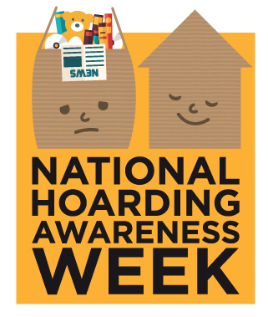
We talked about staffing and recruitment:

- Job titles include court manager, retirement living manager, scheme manager, case worker - tenancy management
- Frontline salaries are mostly in the £18 - £24,000 range
- Most staff costs are subsidised by service charges - including HB-ineligible 'support charges' of between £2 to £4.50 per week
- Vacancies can be advertised on the East Sussex County Council and erosh websites

We talked about what makes a scheme popular. Good location, accessibility and spacious properties are the top factors. Conversely, isolated rural locations, poor accessibility (e.g. scheme on a hill), lack of parking, and bedsit flats are likely to make a scheme difficult to let.

Erosh is leading a campaign to 'celebrate sheltered and retirement housing' this year. There's a short promotional booklet, template letters to send to your local MP and other resources. They're on the erosh website, along with recent good practice guides on mobility vehicles, safeguarding and more.

Our next meeting will be Wednesday 6 September 2017 at AmicusHorizon’s The Orangery extra care scheme in Buxton Drive, Bexhill. We’ll have speakers on managing kitchens/hygiene and safeguarding. We'd like to encourage frontline staff and managers to attend.

Contact: Robin Deane 07703 200253 robin.deane@amicushorizon.org.uk

